

**Pabna University of Science & Technology**

Department of

Information & Communication Engineering

(ICE)

Faculty of Engineering and Technology

Lab Report

**Course Code:** ICE-3208

**Course Title:** Digital Image and Signal Processing Sessional

|  |  |
| --- | --- |
| **Submitted By:**  Name: Rajia Shultana  Roll: 170602  Session: 2016-17  Dept. of Information &  Communication Engineering  Pabna University of Science  and Technology. | **Submitted To:**  Md. Anwar Hossain  Associate Professor  Dept. of Information & Communication Engineering  Pabna University of Science and Technology. |

Submission Date: 14/05/2021 Signature:

**Laboratory Problem List**

|  |  |
| --- | --- |
| Exp No | Problem Description |
| 1. | Write a MATLAB program for (i) negative (ii) Log (iii) power-law transformation of a gray level image. |
| 2. | Write a MATLAB program for (i) showing histogram (ii) contrast stretching (iii) histogram equalization of a gray level image. |
| 3. | Write a MATLAB program for (i) high pass and lowpass filter (ii) average filter (iii) median, max and min filter of a gray level image. |
| 4. | Write a MATLAB program for (i) ideal (ii) Butterworth (iii) Gaussian lowpass and highpass filter of a gray level image in frequency domain. |
| 5. | Write a MATLAB program for (i) Laplacian (ii) homomorphic filter of a gray level image in frequency domain. |
| 6. | Write a MATLAB program for (i) arithmetic and geometric (ii) harmonic and contraharmonic (iii) midpoint and alpha-trimmed mean filter of a gray level image. |
| 7. | Write a MATLAB program for (i) ideal (ii) Butterworth (iii) Gaussian bandreject and bandpass filter of a gray level image. |
| 8. | Write a MATLAB program for Wiener filter of a gray level image. |
| 9. | Write a MATLAB program for separating RGB and HSI components  of a color image. |
| 10. | Write a MATLAB program for smoothing and sharpening of a color image. |
| 11. | Write a MATLAB program for (i) Haar Transform (ii) one dimensional Discrete Wavelet Transform (iii) Discrete Cosine Transform of an image. |
| 12. | Write a MATLAB program for edge detection using Sobel, Canny, Prewitt, Roberts, log, zerocross filter. |
| 13. | Write a MATLAB program to implement a LPF (FIR) with cutoff 8KHz and to denoise audio. |
| 14. | Write a MATLAB program to implement Echo of audio signal. |
| 15. | Write a MATLAB program to record and save single and double channel audio. |
| 16. | Write a MATLAB program to implement Text to Speech signal. |

**Problem No:** 01

**Problem Title:** Write a MATLAB program for (i) negative (ii) Log (iii) power-law transformation of a gray level image.

**Problem Description:**

Negative Transformation: The Negative transformation is probably the easiest of the intensity transformations to describe. Assume that we are working with grayscale double arrays where black is 0 and white is 1. The idea is that 0's become 1's, 1's become 0's, and any gradients in between are also reversed. In intensity, this means that the true black becomes true white and vise versa.

The transformation function used in image negative is :

s = T(r) = (L – 1) – r

Where L - 1 is the max intensity value,

s is the output pixel value and

r is the input pixel value

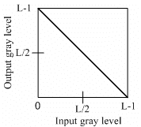

Figure 1: Graphical representation of negative transformations

Log Transformation: Logarithmic Transformations can be used to brighten the intensities of an image (like the Gamma Transformation, where gamma < 1). More often, it is used to increase the detail (or contrast) of lower intensity values. The equation used to get the Logarithmic transform of image r is:

s = c*log(1 +r)

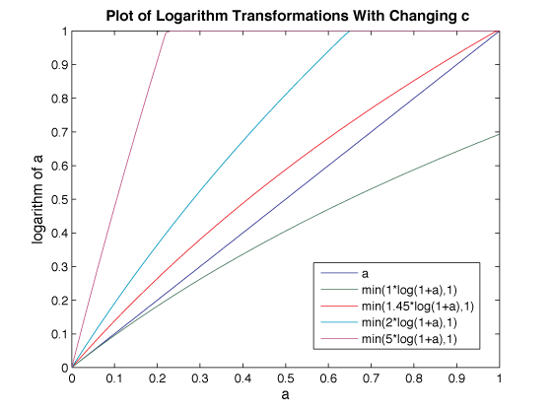

Power-law Transformation: The general form of power law(Gamma) transformation function is,

$s=cr^{γ}$

Where, ‘s’ and ‘r’ are the output pixel value, respectively and c, $γ$ are the positive constants. Variation in the value of γ varies the enhancement of the images.

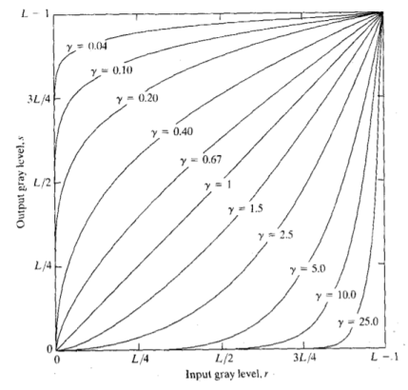

**MatLab Source Code:**

clear all;

close all;

clc;

a=imread('cameraman.tif');

%%Negative transfomation

for i=1:256

for j=1:256

n(i,j)=255-a(i,j);

end

end

%%Log transformation

d=im2double(a);

l=d;

for i=1:256

for j=1:256

l(i,j)=log10(1+d(i,j));

end

end

%%Power-law transformation

for i=1:256

for j=1:256

p(i,j)=power(a(i,j),2);

end

end

subplot(2,3,1);

imshow(a);

title('Orginal image of cameramen','color','r');

subplot(2,3,2);

imshow(n);

title('image after negative transformation');

subplot(2,3,4);

imshow(l);

title('image after log transformation','color','m');

subplot(2,3,5);

imshow(p);

title('image after power law transformation','color','b');

**Input and Output:**

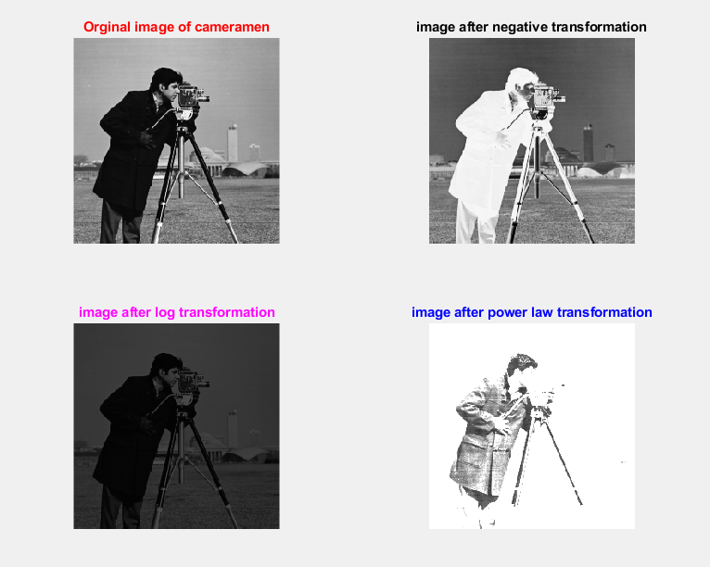

**Problem No:** 02

**Problem Title:** Write a MATLAB program for

1. showing histogram
2. contrast stretching
3. histogram equalization of a gray level image.

**Problem Description:**

Histogram: In digital image processing, the histogram is used for graphical representation of a digital image. A graph is a plot by the number of pixels for each tonal value. Nowadays, image histogram is present in digital cameras. Photographers use them to see the distribution of tones captured.

In a graph, the horizontal axis of the graph is used to represent tonal variations whereas the vertical axis is used to represent the number of pixels in that particular pixel. Black and dark areas are represented in the left side of the horizontal axis, medium gray color is represented in the middle, and the vertical axis represents the size of the area.

Contrast Stretching: Contrast stretching expands the range of intensity levels in an image so that it spans the ideal full intensity range of the recording medium or display device.

If we want to increase the contrast of an image, histogram of that image will be fully stretched and covered the dynamic range of the histogram.

From histogram of an image, we can check that the image has low or high contrast.

Histogram Equalization: Histogram equalization is used for equalizing all the pixel values of an image. Transformation is done in such a way that uniform flattened histogram is produced.

Histogram equalization increases the dynamic range of pixel values and makes an equal count of pixels at each level which produces a flat histogram with high contrast image.

While stretching histogram, the shape of histogram remains the same whereas in Histogram equalization, the shape of histogram changes and it generates only one image.

**MatLab Source Course:**

clear all;

close all;

clc;

%read image

img = imread('pout.tif');

%show histogram

subplot(321); imshow(img); title('Source image');

subplot(322); imhist(img); title('Source image histogram');

%Contrast Streching

cs_img = imadjust(img);

subplot(323); imshow(cs_img); title('Contrast streched image');

subplot(324); imhist(cs_img); title('Contrast streched image histogram');

%Histogram Equalization

histeq_img = histeq(img);

subplot(325); imshow(histeq_img); title('Histogram equalized image');

subplot(326); imhist(histeq_img); title('Histogram equalized image histogram');

**Input and Output:**

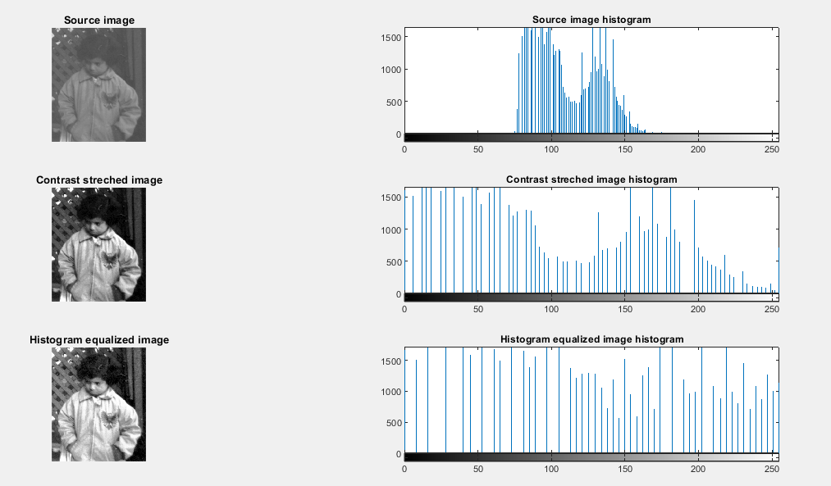

**Problem No:** 03

**Problem Title:** Write a MATLAB program for (i) high pass and lowpass filter (ii) average filter (iii) median, max and min filter of a gray level image.

**Problem Description:**

i)High pass and Low pass filter

Lowpass filter (smoothing): A low pass filter is used to pass low-frequency signals. The strength of the signal is reduced and frequencies which are passed is higher than the cut-off frequency. The amount of strength reduced for each frequency depends on the design of the filter. Smoothing is low pass operation in the frequency domain.

High pass filters (sharpening): A high pass filter is used for passing high frequencies but the strength of the frequency is lower as compared to cut off frequency. Sharpening is a high pass operation in the frequency domain. As lowpass filter, it also has standard forms such as Ideal high pass filter, Butterworth high pass filter, Gaussian high pass filter.

**MatLab Source Code:**

close all;

clear all;

clc;

%read image

img = imread('Fig0333(a)(test_pattern_blurring_orig).tif');

subplot(131); imshow(img); title('Source Image');

%Lowpass filter

LowKernel = [1 1 1; 1 -10 1; 1 1 1];

lp_filt = conv2(LowKernel, img);

subplot(132); imshow(lp_filt); title('Low pass filtered Image');

%Highpass filter

HighKernel = [-1 -1 -1; -1 10 -1; -1 -1 -1];

hp_filt = conv2(HighKernel, img);

subplot(133); imshow(hp_filt); title('Low pass filtered Image');

**Intput and Output:**

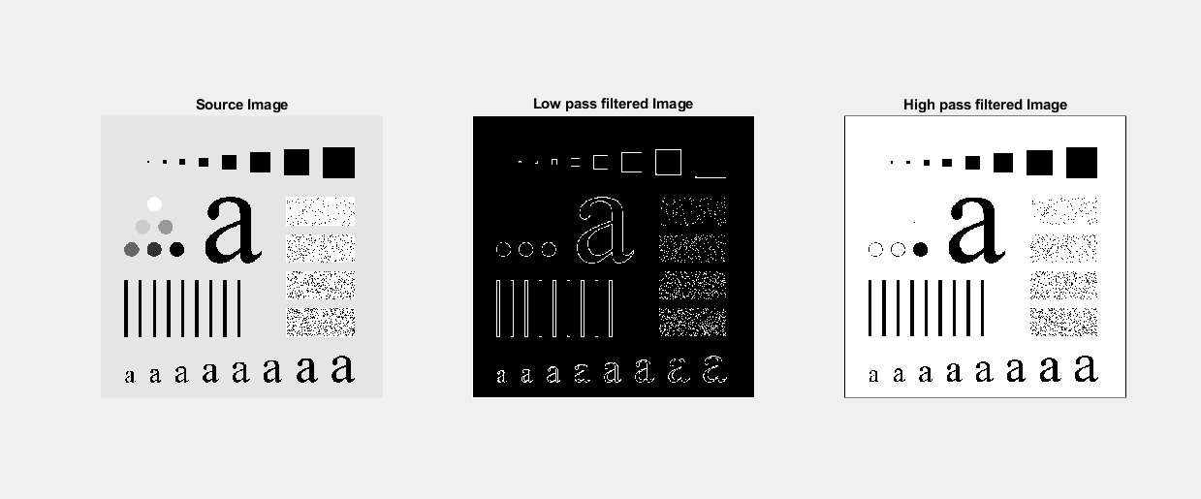

ii)Average filter

Average (or mean) filtering is a method of 'smoothing' images by reducing the amount of intensity variation between neighboring pixels. The average filter works by moving through the image pixel by pixel, replacing each value with the average value of neighboring pixels, including itself.

**Matlab Source Code:**

%Average filter

close all;

clear all;

clc;

%read image

img = imread('Fig0333(a)(test_pattern_blurring_orig).tif');

subplot(231); imshow(img); title('Source Image');

m3 = fspecial('average',3);

m9 = fspecial('average',9);

m15 = fspecial('average',15);

m25 = fspecial('average',25);

m35 = fspecial('average',35);

J3 = imfilter(img,m3);

J9 = imfilter(img,m9);

J15 = imfilter(img,m15);

J25 = imfilter(img,m25);

J35 = imfilter(img,m35);

subplot(232); imshow(J3); title('Average filtered by 3X3');

subplot(233); imshow(J9); title('Average filtered by 9X9');

subplot(234); imshow(J15); title('Average filtered by 15X15');

subplot(235); imshow(J25); title('Average filtered by 25X25');

subplot(236); imshow(J35); title('Average filtered by 35X35');

**Input and Output:**

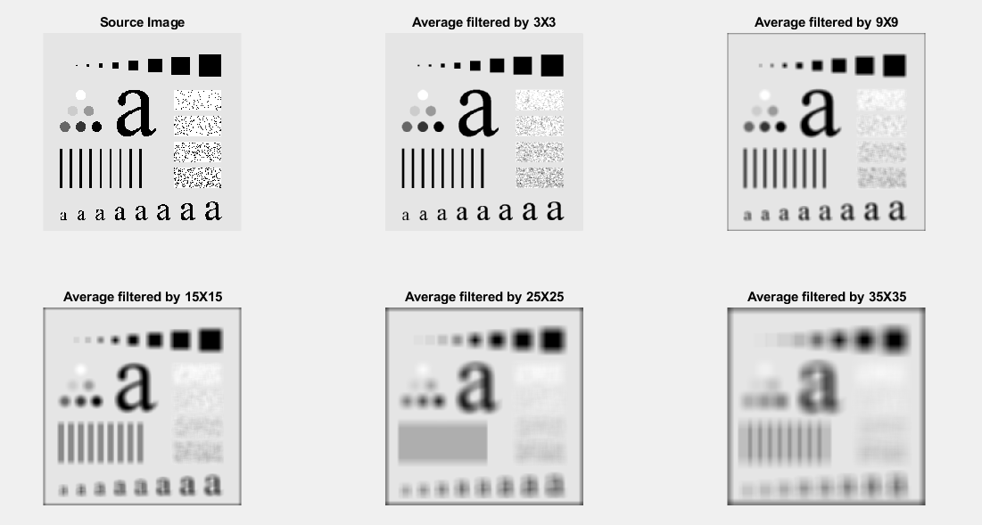

iii)Median, Max and Min filter

Median Filter : The median filter is a non-linear digital filtering technique, often used to remove noise from an image or signal. Such noise reduction is a typical pre-processing step to improve the results of later processing (for example, edge detection on an image).

Max Filter: The maximum filter is defined as the maximum of all pixels within a local region of an image. The maximum filter is typically applied to an image to remove negative outlier noise.

Min Filter: The minimum filter is defined as the minimum of all pixels within a local region of an image. The minimum filter is typically applied to an image to remove positive outlier noise.

**Matlab Source Code:**

%Median, max, min filter;

close all;

clear all;

clc;

%read image

i = imread('cameraman.tif');

i1 = im2double(i);

figure(3);

subplot(231); imshow(i); title('Source Image');

noisy_img = imnoise(i1,'salt & pepper');

subplot(232); imshow(noisy_img); title('Salt & Pepper noisy image');

%Median fitlering window 3*3

medf_img = ordfilt2(noisy_img,5, ones(3,3));

subplot(233); imshow(medf_img); title('Median filtered image');

%max, min filtering window 3*3

subplot(234); imshow(i); title('Source Image');

maxf_img = ordfilt2(noisy_img,9, ones(3,3));

subplot(235); imshow(maxf_img); title('Max filtered image');

minf_img = ordfilt2(noisy_img,1, ones(3,3));

subplot(236); imshow(minf_img); title('Min filtered image');

**Input and Output:**

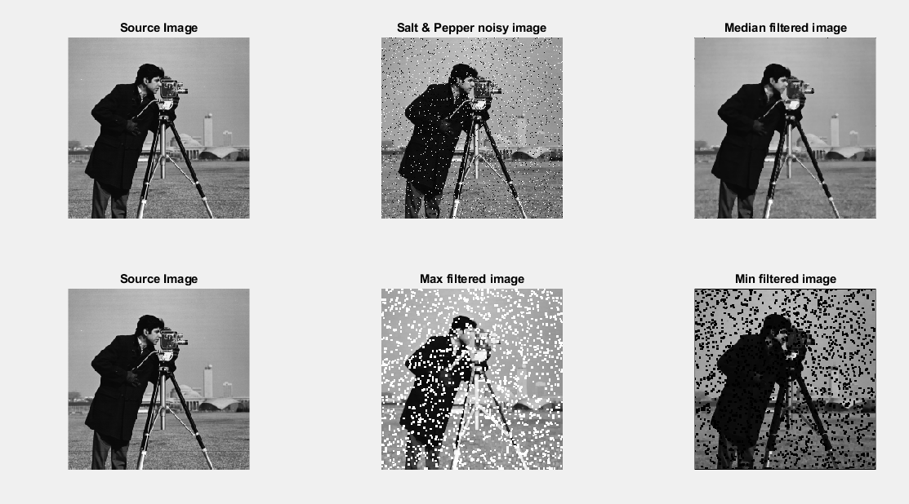

**Problem No:** 04

**Problem Title:** Write a MATLAB program for (i) ideal (ii) Butterworth (iii) Gaussian lowpass and highpass filter of a gray level image in frequency domain.

**Problem description:**

i)Ideal low-pass and high-pass filter

Ideal lowpass filter **(ILPF)** : In the field of Image Processing, Ideal Lowpass Filteris used for image smoothing in the frequency domain. It removes high-frequency noise from a digital image and preserves low-frequency components.

It can be specified by the function-

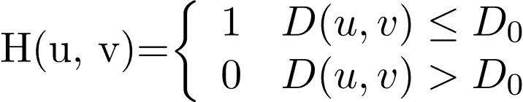

Where,

D0 is a positive constant. ILPF passes all the frequencies within a circle of radius D0 from the origin without attenuation and cuts off all the frequencies outside the circle.

This D0 is the transition point between H(u, v) = 1 and H(u, v) = 0, so this is

termed as **cutoff frequency**.

D(u,v) is the Euclidean Distance from any point (u, v) to the origin of the

frequency plane, i.e, 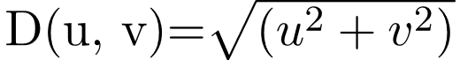

Ideal hightpass filter:

In the field of Image Processing, **Ideal Highpass Filter (IHPF)** is used for image sharpening in the frequency domain. Image Sharpening is a technique to enhance the fine details and highlight the edges in a digital image. It removes low-frequency components from an image and preserves high-frequency components.

This ideal highpass filter is the reverse operation of the ideal lowpass filter. It can be determined using the following relation-

   
where, 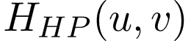 is the transfer function of the highpass filter and 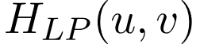 is the transfer function of the corresponding lowpass filter.

The transfer function of the IHPF can be specified by the function-

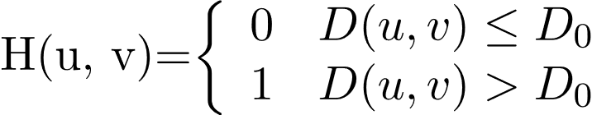

Where,

* D0is a positive constant. IHPF passes all the frequencies outside of a circle of radius D0 from the origin without attenuation and cuts off all the frequencies within the circle.
* This D0 is the transition point between H(u, v) = 1 and H(u, v) = 0, so this is termed as cutoff frequency.
* D(u,v) is the Euclidean Distance from any point (u, v) to the origin of the frequency plane, i.e,



**Matlab Source Code:**

close all;

clear all;

clc;

i_img = imread('input17.png');

[r,c] = size(i_img);

figure(1);

subplot(131); imshow(i_img); title('Source Image');

FT_img = fft2(double(i_img));

%Assign cut off frequency

D0 = 30;

%creating filter

u = 0:(r-1);

idx = find(u>r/2);

u(idx) = u(idx)-r;

v = 0:(c-1);

idy = find(v>c/2);

v(idy) = v(idy)-c;

[V, U] = meshgrid(v, u);

%Calculating Euclidean Distance

D = sqrt(U.^2 + V.^2);

%Comparing with the cut-off frequency and determining the filtering mask

%%%real low-pass filter

l = double(D<=D0);

%Convolution between Fourier Transformed image and mask

Rlp_filt = l.*FT_img;

o_img = real(ifft2(Rlp_filt));

subplot(132); imshow(o_img,[]); title('Ideal Low-pass filtered image');

%%5 Real high-pass filter

H = double(D > D0);

Rhp_filt = H.*FT_img;

output_image = real(ifft2(double(Rhp_filt)));

subplot(133), imshow(output_image, [ ]); title('Ideal High-pass filtered image');

**Input and Output**:

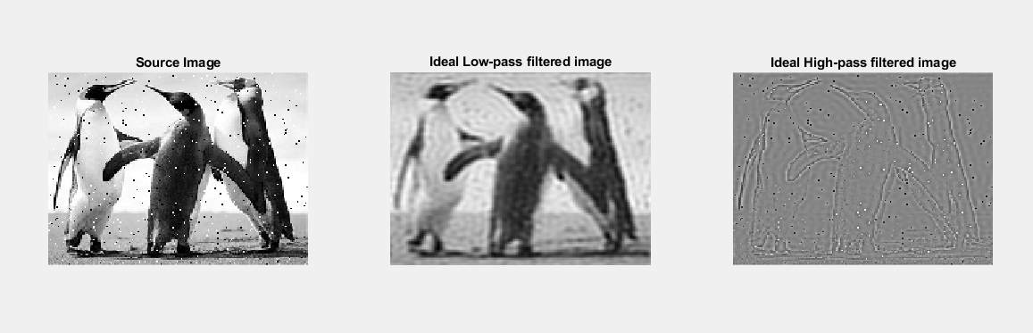

ii) Butterworth lowpass and highpass filter

Butterworth lowpass filter:In the field of Image Processing, Butterworth Lowpass Filter (BLPF) is used for image smoothing in the frequency domain. It removes high-frequency noise from a digital image and preserves low-frequency components. The transfer function of BLPF of order n is defined as-

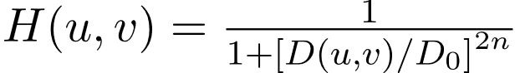

Butterworth highpass filter: In the field of Image processing, Butterworth Highpass Filter (BHPF) is used for image sharpening in the frequency domain. Image Sharpening is a technique to enhance the fine details and highlight the edges in a digital image. It removes low-frequency components from an image and preserves high-frequency components.

The transfer function of BHPF of order n is defined as-

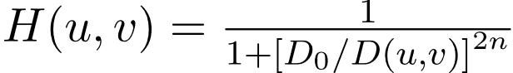

**Matlab Source Code:**

%%%%%Butterworth lowpass and highpass filter

close all;

clear all;

clc;

i_img = imread('cameraman.tif');

[r,c] = size(i_img);

figure(1);

subplot(131); imshow(i_img); title('Source Image');

FT_img = fft2(double(i_img));

%Assign cut off frequency

D0 = 30;

%creating filter

u = 0:(r-1);

idx = find(u>r/2);

u(idx) = u(idx)-r;

v = 0:(c-1);

idy = find(v>c/2);

v(idy) = v(idy)-c;

[V, U] = meshgrid(v, u);

%Calculating Euclidean Distance

D = sqrt(U.^2 + V.^2);

% Assign the order value

n = 2; % one can change this value accordingly

%%% Butterworth low-pass filter

%determining the filtering mask

H1 = 1./(1 + (D./D0).^(2*n));

% Convolution between the Fourier Transformed image and the mask

Blp_filt = H1.*FT_img;

but_img = real(ifft2(double(Blp_filt)));

subplot(132); imshow(but_img,[]); title('Butterworth Low-pass filtered image');

%%% Butterworth high-pass filter

% determining the filtering mask

Hp = 1./(1 + (D0./D).^(2*n));

% Convolution between the Fourier Transformed

% image and the mask

Bhp_filt = Hp.*FT_img;

output_image = real(ifft2(double(Bhp_filt)));

% Displaying Input Image and Output Image

subplot(1, 3, 3), imshow(output_image, [ ]); title('Butterworth High-pass filtered image');

**Input and Output:**

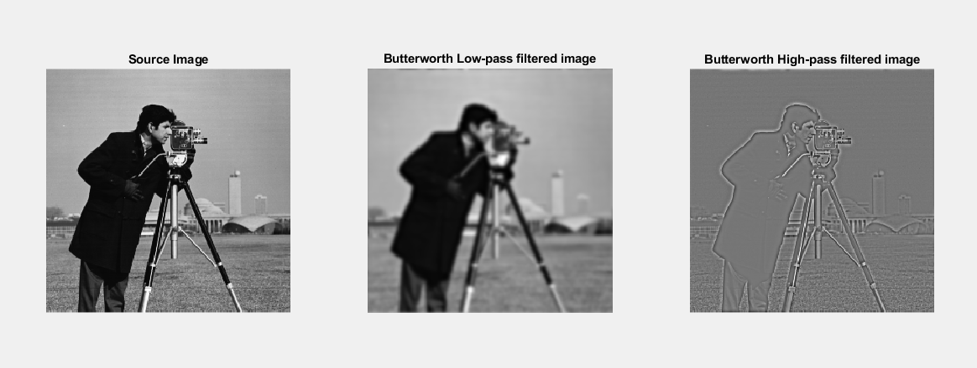

iii) Gaussian lowpass and highpass filter

Gaussian low pass and Gaussian high pass filter minimize the problem that occur in ideal low pass and high pass filter. This problem is known as ringing effect. This is due to reason because at some points transition between one color to the other cannot be defined precisely, due to which the ringing effect appears at that point.

The transfer function of Gaussian lowpass filter is defined as-

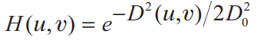

The transfer function of Gaussian highpass filter is defined as-

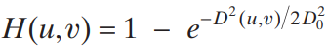

**Matlab Source Code:**

%---------------------------------------------------------%

%--Gaussian Low pass and High pass filter --------------------%

%---------------------------------------------------------%

clc;

clear all;

close all;

d0= 30;

image=imread('pout.tif');

[r ,c]=size(image);

img_f = fft2(double(image));% Fourier transform to get the spectrum

img_f=fftshift(img_f);% move to the middle

% center point coordinates

m_mid=floor(r/2);

n_mid=floor(c/2);

%% Gaussian low-pass filter construction

l = zeros(r,c);

for i = 1:r

for j = 1:c

d = ((i-m_mid)^2+(j-n_mid)^2);

l(i,j) = exp(-d/(2*(d0^2)));

end

end

img_glpf = l.*img_f;

img_glpf = ifftshift(img_glpf);% center shift back to the original state

img_glpf = uint8(real(ifft2(img_glpf)));% inverse Fourier transform, take the real part

%% Gaussian high-pass filter construction

h = zeros(r,c);

for i = 1:r

for j = 1:c

d = ((i-m_mid)^2+(j-n_mid)^2);

h(i,j) = 1 - exp(-d/(2*(d0^2)));

end

end

img_ghpf = h.*img_f;

img_ghpf = ifftshift(img_ghpf);% center shift back to the original state

img_ghpf = uint8(real(ifft2(img_ghpf)));% inverse Fourier transform, take the real part

subplot(1,3,1);imshow(image);title('Original image');

subplot(1,3,2);imshow(img_glpf,[]);title('Gaussian low-pass filtered image');

subplot(1,3,3);imshow(img_ghpf,[]);title('Gaussian high-pass filtered image');

**Input and Output:**

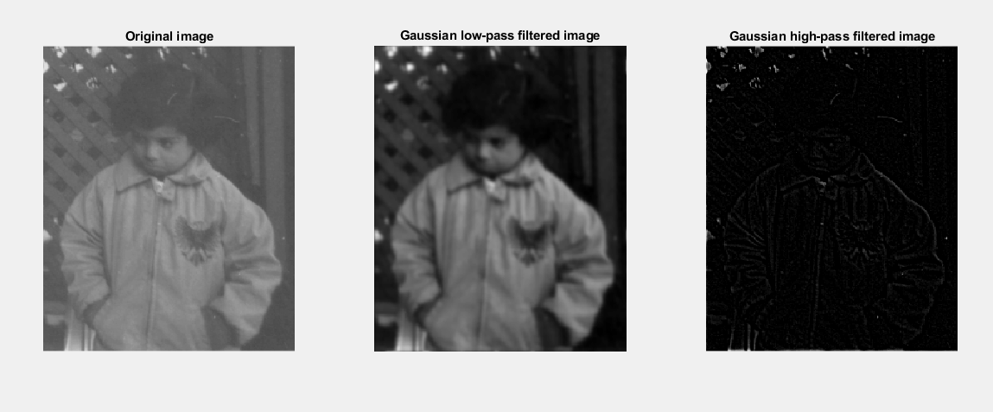

**Problem No:** 05

**Problem Title:** Write a MATLAB program for (i) Laplacian (ii) homomorphic filter of a gray level image in frequency domain.

**Problem Description:**

(i) Laplacian Filter

The Laplacian of an image highlights regions of rapid intensity change and is an example of a second order or a second derivative method of enhancement. It is particularly good at finding the fine details of an image. Any feature with a sharp discontinuity will be enhanced by a Laplacian operator. The Laplacian is a well-known linear differential operator approximating the second derivative given by equation.



where f denotes the image.

**Matlab Source Code:**

clc;

clear all;

close all;

% A read image, and converted to a double

I=imread('cameraman.tif');

I_D=im2double(I);

% Of the image height and width is obtained

[M,N]=size(I_D);

% Center of the image

M0=M/2;

N0=N/2;

J=fft2(I_D);

J_shift=fftshift(J);

A=2;

for x=1:M

for y=1:N

h_hp=1+4*((x-M0)^2+(y-N0)^2)/(M0*N0);

h_bp=(A-1)+h_hp;

J_shift(x,y)=J_shift(x,y)*h_bp;

end

end

J=ifftshift(J_shift);

I_D_rep=ifft2(J);

subplot(1,2,1); imshow(I); title('Source Image');

subplot(1,2,2); imshow(I_D_rep); title('Laplacian filtered image');

**Input and Output:**

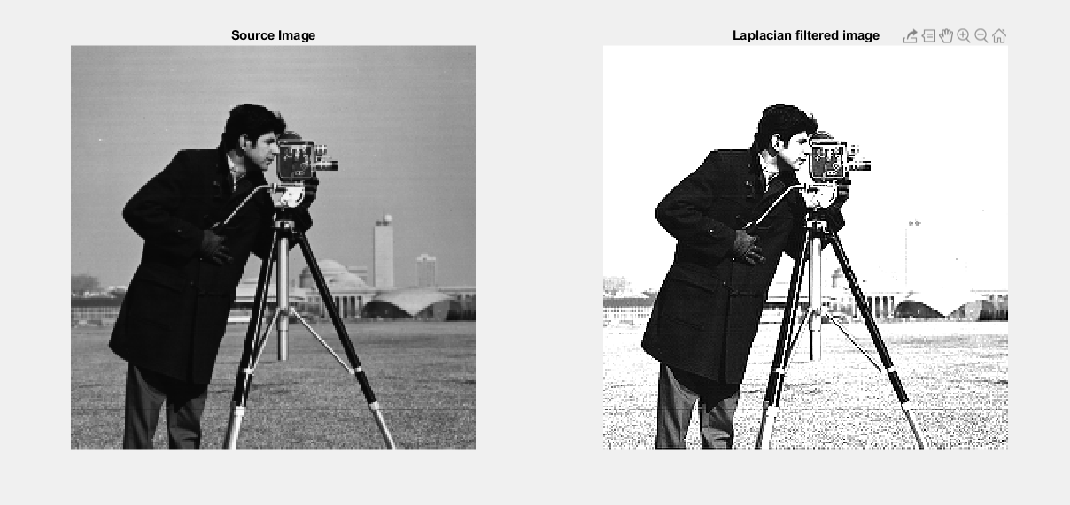

**Homomorphic filtering:** Is an image processing method that combines frequency filtering and spatial grayscale transformation, which is based on the illumination of the image./The reflectivity model serves as the basis for frequency domain processing, using compressed luminance ranges and enhanced contrast to improve image quality.

The basic principles of homomorphic filtering are described below.

An image can be seen as consisting of two parts, namely

among them, fi representing the light intensity that varies with space the component, which is characterized by a slow change, is concentrated in the low frequency part of the image. fr Represents the reflection of the scene reflected to the human eye (Reflectance) component. Its features include a variety of information on the scene, high-frequency components.

**Matlab Source Code:**

clc;

clear all;

close all;

% Parameter declaration

rH = 1;

rL = 0.1;

c = 0.2;% is between rH and rL

D0 = 0.2;

image = imread('cameraman.tif');

[M, N] = size(image);

% Logarithm

img_log = log(double(image) + 1);

% Shift to the center, judgment sentence replaces index calculation

img_py = zeros(M, N);

for i = 1:M

for j= 1:N

if mod(i+j, 2) == 0

img_py(i,j) = img_log(i, j);

else

img_py(i,j) = -1 * img_log(i, j);

end

end

end

% Perform Fourier transform on the filled image

img_py_fft = fft2(img_py);

% Homomorphic filter function

img_tt = zeros(M, N);

deta_r = rH - rL;

D = D0^2;

m_mid=floor(M/2);% center point coordinates

n_mid=floor(N/2);

for i = 1:M

for j =1:N

dis = ((i-m_mid)^2+(j-n_mid)^2);

img_tt(i, j) = deta_r * (1-exp((-c)*(dis/D))) + rL;

end

end

% Filtering

img_temp = img_py_fft.*img_tt;

% Inverse transformation, take real part, absolute value

img_temp = abs(real(ifft2(img_temp)));

% Indexed

img_temp = exp(img_temp) - 1;

% Normalization

max_num = max(img_temp(:));

min_num = min(img_temp(:));

range = max_num - min_num;

img_after = zeros(M,N,'uint8');

for i = 1 : M

for j = 1 : N

img_after(i,j) = uint8(255 * (img_temp(i, j)-min_num) / range);

end

end

subplot(1,2,1), imshow(image), title('Source image');

subplot(1,2,2), imshow(img_after), title('Homomorphic filtered image’);

**Input and Output:**

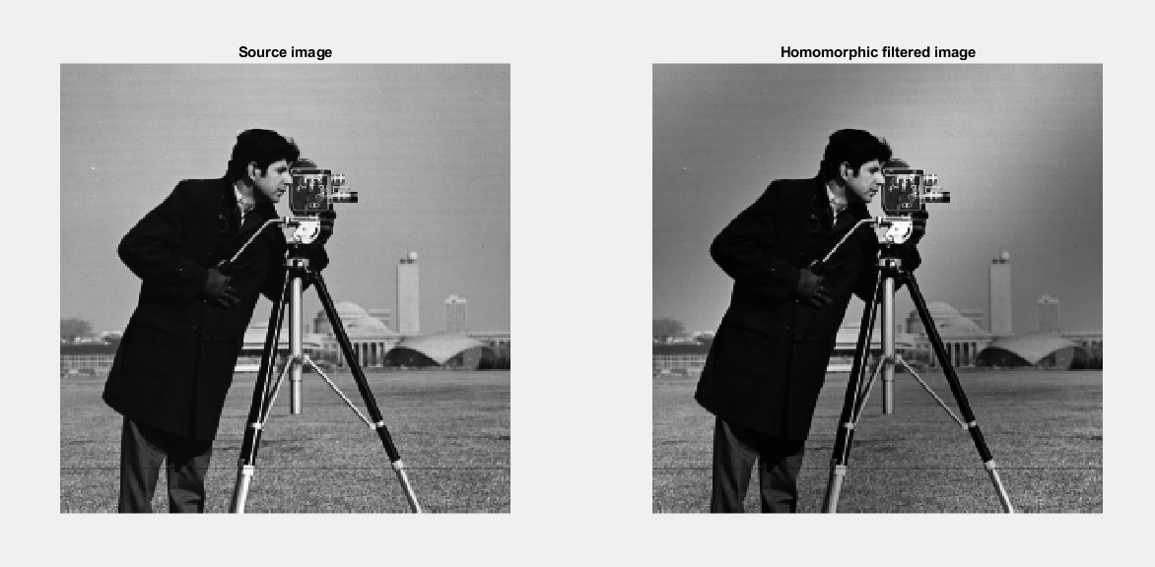

**Problem No:** 06

**Problem Title:** Write a MATLAB program for (i) arithmetic and geometric (ii) harmonic and contraharmonic (iii) midpoint and alpha-trimmed mean filter of a gray level image.

**Problem Description:**

(i) Arithmetic and Geometric Filter

Arithmetic mean filter

This is the simplest of the mean filters. Let Sxv represent the set of coordinates in a rectangular subimage window of size m X n, centered at point (x, y).The arithmetic mean filtering process computes the average value of the corrupted image g(x, y) in the area defined by Sxy.The value of the restored image at any point (x, y) is simply the arithmetic mean computed using the pixels in the region defined by S. In other words.

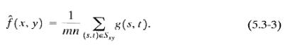

This operation can be implemented using a convolution mask in which ail coefficients have value 1/mm. Noise is reduced as a result of blurring.

Geometric mean filter:

An image restored using a geometric mean filter is given by the expression

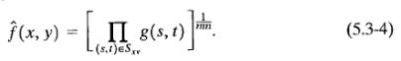

Here, each restored pixel is given by the product of the pixels in the subimage window, raised to the power 1/mn

**MatLab Source Code:**

clc;

clear all;

close all;

% Arithmetic Mean Filter and Geometric Mean Filter

img=imread('cameraman.tif');

[r,c]=size(img);

img=im2double(img);

subplot(221);

imshow(img);

title('Source image');

%%%Adding Gaussian Noise

noisy_img=imnoise(img,'gaussian');

subplot(222);

imshow(noisy_img);

title('Gaussian noisy image');

%%% 'valid' convolution(3*3) , so image dimension will be reduced

for i=1:r-2

for j=1:c-2

window = noisy_img(i:i+2,j:j+2);

amf_img(i,j)= mean( window(:) );

gmf_img(i,j)= geomean( window(:) );

end

end

subplot(223);

imshow(amf_img);

title('AMF filtered image');

subplot(224);

imshow(gmf_img);

title('GMF filtered image');

**Input and Output:**

ii) Harmonic and Contraharmonic Filter

Harmonic mean filter: The harmonic mean filtering operation is given by the expression

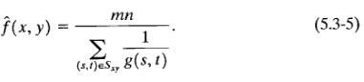

The harmonic mean filter works well for salt noise, but fails for pepper noise. It does well also with other types of noise tike Gaussian noise.

### Contraharmonic mean filter : The contraharmonic mean filtering operation yields a restored image based on the expression

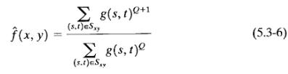

where Q is called the order of the filter. This filter is well suited for reducing or virtually eliminating the effects of salt-and-pepper noise. For positive values of Q, the filter eliminates pepper noise. For negative values of Q it eliminates salt noise. It cannot do both simultaneously. Note that the contraharmonic filter reduces to the arithmetic mean filter if Q = 0, and to the harmonic mean filter if Q = - 1

**MatLab Source Code:**

clc;

clear all;

close all;

% Harmonic Mean Filter and Conrtaharmonic Mean Filter

img=imread('cameraman.tif');

[r,c]=size(img);

img=im2double(img);

subplot(221);

imshow(img);

title('Source image');

%%%Adding Gaussian Noise

noisy_img=imnoise(img,'gaussian');

subplot(222);

imshow(noisy_img);

title('Gaussian noisy image');

%%% 'valid' convolution(3*3) , so image dimension will be reduced

Q=1.5;

for i=1:r-2

for j=1:c-2

window = noisy_img(i:i+2,j:j+2);

hmf_img(i,j)= harmmean( window(:) );

chmf_img(i,j)= sum( window(:).^(Q+1) ) ./ sum( window(:).^Q );

end

end

subplot(223);

imshow(hmf_img);

title('HMF filtered image');

subplot(224);

imshow(chmf_img);

title('CHMF filtered image');

**Input and Output:**



iii) Midpoint and Alpha-Trimmed Mean Filter

Midpoint Filter: The midpoint filter is typically used to filter images containing short tailed noise such as Gaussian and uniform type noises. The midpoint filter is defined as : where the coordinate (x+i, y+j ) is defined over the image A and the coordinate (i, j) is defined over the N x N size square mask.

Alpha-Trimmed Mean Filter: The modified alpha mean filter is similar to the method of removing the highest score and removing the lowest score to evaluate a player's level, that is, sort the data in the filtering range, remove d data from large to small, and remove d from small to large Data, calculate the average of the remaining data. Such filters are very good at removing pictures that have been contaminated by salt and pepper noise along with

other types of noise.

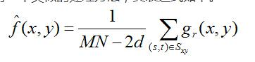

**MatLab Source Course:**

clc;

clear all;

close all;

% Midpoint Filter ( MF )

img=imread('cameraman.tif');

[r,c]=size(img);

img=im2double(img);

subplot(221);

imshow(img);

title('Source image');

%%% Adding Gaussian Noise

noisy_img=imnoise(img,'Gaussian');

subplot(222);

imshow(noisy_img);

title('Gaussian noisy image');

%%% Filtering , window 3*3

midf_img= ( ordfilt2(noisy_img,9,ones(3,3)) + ordfilt2(noisy_img,1,ones(3,3)) )./2 ;

subplot(223);

imshow(midf_img);

title('Midpoint filtered image');

% Alpha-trimmed Mean Filter ( ATMF )

%%% 'valid' convolution(3*3) , so image dimension will be reduced

d=25; %percent

for i=1:r-2

for j=1:c-2

window = noisy_img(i:i+2,j:j+2);

atmf_img(i,j)= trimmean( window(:),d );

end

end

subplot(224);

imshow(atmf_img);

title('ATMF filtered image');

**Input and Output:**



**Problem No:** 07

**Problem Title:** Write a MATLAB program for (i) ideal (ii) Butterworth (iii) Gaussian bandreject and bandpass filter of a gray level image.

**Problem Description:**

Bandpass and bandreject filter transfer functions in the frequency domain can be constructed by combining lowpass and highpass filter transfer functions. In other words, the lowpass filter transfer functions are the basis for forming highpass, bandreject and bandpass filter functions. A bandpass filter transfer function is obtained from a band-reject function:



The key requirements of a bandpass transfer function are: (1) the values of the function must be in the range [0,1]; (2) the value of the function must be zero at a distant from the origin of the function; and (3) we must be able to specify a value for .

Ideal (IBRF)



Gaussian (GBRF)



Butterworth(BBRF)



(i) Ideal band-pass and band-reject filter

**MatLab Source Code:**

clc;

clear all;

close all;

% Ideal Bandreject Filter(IBRF)

img=imread('cameraman.tif');

[r,c]=size(img);

imshow(img);

title('Source image');

[u,v]=meshgrid(-floor(c/2):floor((c-1)/2),-floor(r/2):floor((r-1)/2));

%%%Adding Noise

sin_noise= 15*sin( 2*pi*1/10*u + 2*pi*1/10*v);

noisy_img=double(img)+sin_noise;

NOISY_IMG=fftshift(fft2(noisy_img));

figure(2)

subplot(231);

imshow(noisy_img,[]);

title('Sinusoidal noisy image')

subplot(234);

imshow(mat2gray(log(1+abs(NOISY_IMG))));

title('FFT of noisy image');

%%%Creating filter

D=sqrt(u.^2+v.^2);

D0=50;

W=40;

IBRF= ( D<(D0-W/2) | D>(D0+W/2) );

subplot(232);

mesh(IBRF);

title('IBRF');

IBRF_IMG=NOISY_IMG.*IBRF;

ibrf_img=ifft2(IBRF_IMG);

subplot(233);

imshow(mat2gray(abs(ibrf_img)));

title('IBRF filtered image');

% Ideal Bandpass Filter(IBPF)

IBPF= 1 - IBRF ;

subplot(235);

mesh(IBPF);

title('IBPF')

IBPF_IMG=NOISY_IMG.*IBPF;

ibpf_img=ifft2(IBPF_IMG);

subplot(236);

imshow(mat2gray(abs(ibpf_img)));

title('IBPF filtered image');

**Input and Output:**



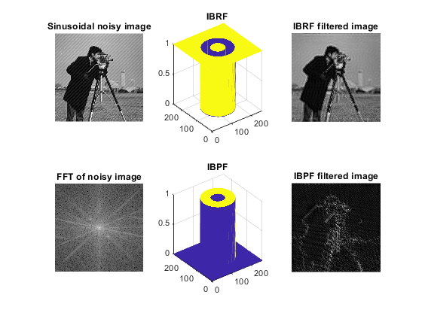

(ii) Butterworth band-pass and band-reject filter

**MatLab Source Code:**

clc;clear all;close all;

% Butterworth Bandreject Filter(BBRF)

img=imread('cameraman.tif');

[r,c]=size(img);

imshow(img);title('Source image');

[u,v]=meshgrid(-floor(c/2):floor((c-1)/2),-floor(r/2):floor((r-1)/2));

%%%Adding Noise

sin_noise= 15*sin( 2*pi*1/10*u + 2*pi*1/10*v);

noisy_img=double(img)+sin_noise;

NOISY_IMG=fftshift(fft2(noisy_img));

figure(2)

subplot(231);imshow(noisy_img,[]);title('Sinusoidal noisy image');

subplot(234);imshow(mat2gray(log(1+abs(NOISY_IMG))));title('FFT of noisy image');

%%%Creating filter

D=sqrt(u.^2+v.^2);

D0=50;

n=1;

W=20;

BBRF=1./( 1.+ ( (D.*W) ./ (D.^2-D0.^2) ) .^(2*n) );

subplot(232);mesh(BBRF);title('BBRF')

BBRF_IMG=NOISY_IMG.*BBRF;

bbrf_img=ifft2(BBRF_IMG);

subplot(233);imshow(mat2gray(abs(bbrf_img)));title('BBRF filtered image')

% Butterworth Bandpass Filter(BBPF)

BBPF= 1 - BBRF;

subplot(235);mesh(BBPF);title('BBPF')

BBPF_IMG=NOISY_IMG.*BBPF;

bbpf_img=ifft2(BBPF_IMG);

subplot(236);imshow(mat2gray(abs(bbpf_img)));title('BBPF filtered image')

**Input and Output:**

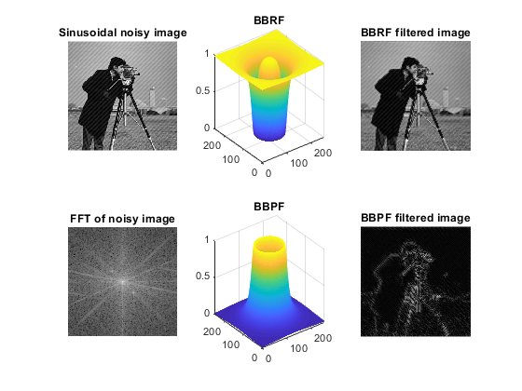

(iii) Gaussian band-pass and band-reject filter

**MatLab Source Code:**

clc;clear all;close all

% Gaussian Bandreject Filter(GBRF)

img=imread('cameraman.tif');

[r,c]=size(img);

imshow(img);title('Source image')

[u,v]=meshgrid(-floor(c/2):floor((c-1)/2),-floor(r/2):floor((r-1)/2));

%%%Adding Noise

sin_noise= 15*sin( 2*pi*1/10*u + 2*pi*1/10*v);

noisy_img=double(img)+sin_noise;

NOISY_IMG=fftshift(fft2(noisy_img));

figure(2)

subplot(231);imshow(noisy_img,[]);title('Sinusoidal noisy image');

subplot(234);imshow(mat2gray(log(1+abs(NOISY_IMG))));title('FFT of noisy image');

%%%Creating filter

D=sqrt(u.^2+v.^2);

D0=50;

W=20;

GBRF= 1 - exp ( -(1/2).* ( ((D.^2)-(D0.^2)) ./ (D.*W) ).^2 ) ;

subplot(232);mesh(GBRF);title('GBRF');

GBRF_IMG=NOISY_IMG.*GBRF;

gbrf_img=ifft2(GBRF_IMG);

subplot(233);imshow(mat2gray(abs(gbrf_img)));title('GBRF filtered image');

% Gaussian Bandpass Filter(GBPF)

GBPF=1 - GBRF;

subplot(235);mesh(GBPF);title('GBPF');

GBPF_IMG=NOISY_IMG.*GBPF;

gbpf_img=ifft2(GBPF_IMG);

subplot(236);imshow(mat2gray(abs(gbpf_img)));title('GBPF filtered image');

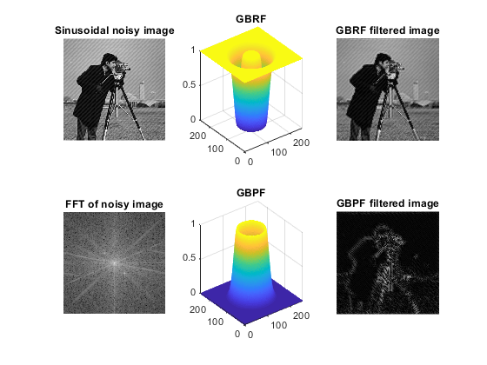**Input and Output:**

**Problem No:** 08

**Problem Name:** Write a MATLAB program for Wiener filter of a gray level image.

**Problem Description:**

The Wiener filter is the MSE-optimal stationary **linear** filter for images degraded by additive noise and blurring. Calculation of the Wiener filter requires the assumption that the signal and noise processes are second-order stationary (in the random process sense). For this description, only noise processes with zero mean will be considered (this is without loss of generality).

Wiener filters are usually applied in the frequency domain. Given a degraded image *x*(*n*,*m*), one takes the Discrete Fourier Transform (DFT) to obtain *X*(*u*,*v*). The original image spectrum is estimated by taking the product of *X*(*u*,*v*) with the Wiener filter *G*(*u*,*v*):



The inverse DFT is then used to obtain the image estimate from its spectrum. The Wiener filter is defined in terms of these spectra:

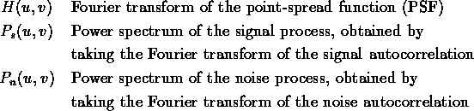

The Wiener filter is:



Dividing through by  makes its behaviour easier to explain:

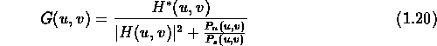

The term  can be interpreted as the reciprocal of the signal-to-noise ratio. Where the signal is very strong relative to the noise,  and the Wiener filter becomes  - the inverse filter for the PSF. Where the signal is very weak,  and  .

For the case of additive white noise and no blurring, the Wiener filter simplifies to:



where  is the noise variance.

Wiener filters are unable to *reconstruct* frequency components which have been degraded by noise. They can only suppress them. Also, Wiener filters are unable to restore components for which *H*(*u*,*v*)=0. This means they are unable to undo blurring caused by band-limiting of *H*(*u*,*v*). Such band-limiting occurs in any real-world imaging system.

Obtaining  can be problematic. One can assume that  has a parametric shape, for example exponential or Gaussian. Alternately,  can be estimated using images representative of the class of images being filtered. For Wiener results presented in this thesis,  was calculated from image to be filtered:  was assumed to be radially symmetric, i.e.  and was estimated by averaging over 30 radial frequency bands. Linear interpolation was used to give  a smooth shape.

**MatLab Source Code:**

clc;

clear all;

close all;

% Minimum Mean Square Error Filter( Wiener Filter )

img=imread('cameraman.tif');

subplot(131)

imshow(img)

title('Source image')

%%%Adding Gaussian Noise

noisy_img=imnoise(img,'gaussian');

subplot(132);

imshow(noisy_img);

title('Gaussian noisy image');

wiener_img=wiener2(noisy_img,[5 5]);

subplot(133); imshow(wiener_img); title('Wiener filtered image')

**Input and Output:**



**Problem No:** 09

**Problem Title:** Write a MATLAB program for separating RGB and HSI components of a color image.

**Problem Description:**

RGB Color Model: In the RGB model, an image consists of three independent image planes, one in each of the primary colors: red, green and blue. Specifying a particular color is by specifying the amount of each of the primary components present. Figure 1 shows the geometry of the RGB color model for specifying colors using a Cartesian coordinate system. The greyscale spectrum, i.e. those colors made from equal amounts of each primary, lies on the line joining the black and white vertices.

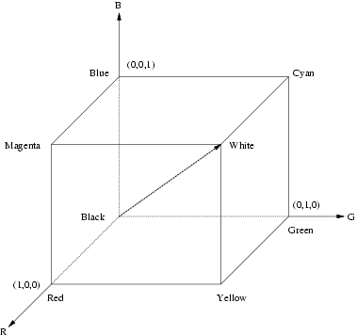Figure

Figure 1: The RGB color cube. The greyscale spectrum lies on the line joining the black and white vertices.

This is an *additive* model, i.e. the colors present in the light add to form new colors, and is appropriate for the mixing of colored light for example. The RGB model is used for color monitors and most video cameras.

HSI Color Model: HSI stands for hue, saturation, intensity. This model is interesting because it can initially seem less intuitive than the RGB model, despite the fact that it describes color in a way that is much more consistent with human visual perception.

**MatLab Source Code:**

clc;clear all;close all;

rgb_img=imread('peppers.png');

rgb_img=im2double(rgb_img);

figure(1)

subplot(221);imshow(rgb_img);title('Original RGB image');

% Separating RGB components

R=rgb_img; R(:,:,2)=0; R(:,:,3)=0;

G=rgb_img; G(:,:,1)=0; G(:,:,3)=0;

B=rgb_img; B(:,:,1)=0; B(:,:,2)=0;

subplot(222);imshow(R);title('Red component');

subplot(223);imshow(G);title('Green component');

subplot(224);imshow(B);title('Blue component');

figure(2)

subplot(221);imshow(rgb_img);title('RGB image');

hsi_img=rgb2hsv(rgb_img);

% Separating HSI components

H=hsi_img; H(:,:,2)=0; H(:,:,3)=0;

S=hsi_img; S(:,:,1)=0; S(:,:,3)=0;

I=hsi_img; I(:,:,1)=0; I(:,:,2)=0;

subplot(222);imshow(H);title('Hue component');

subplot(223);imshow(S);title('Saturation component');

subplot(224);imshow(I);title('Intensity component');

**Input and Output:**





**Problem No:** 10

**Problem Title:** Write a MATLAB program for smoothing and sharpening of a color image.

**Problem Description:**

Color Image Smoothing: Gray-scale image smoothing can be viewed as a spatial filtering operation in which the coefficients of the filtering mask are all 1's. As the mask is slid across the image to be smoothed, each pixel is replaced by the average of the pixels in the neighborhood defined by the mask. This concept is easily extended to the processing of full-color images. The principal difference is that instead of scalar gray-level values we must deal with component vectors of the form given in Equation.

Let Sxy denote the set of coordinates defining a neighborhood centered at ( x, y ) in a RGB color image. The average of the RGB component vectors in this neighborhood is



It follows from Equation and the properties of vector addition that







When recognize the components of this vector as the scalar images that would be obtained by independently smoothing each plane of the starting RGB image using conventional gray-scale neighborhood processing. Thus, we conclude that smoothing by neighborhood averaging can be carried out on a per-color-plane basis. This result is the same as when the averaging is performed using RGB color vectors.

Color Image sharpening: We consider image sharpening using the Laplacian. From vector analysis, we know that the Laplacian of a vector is defined as a vector whose components are equal to the Laplacian of the individual scalar components of the input vector. In the RGB color system, the Laplacian of vector c in Equation is,







which, as in the previous section, tells us that we can compute the Laplacian of a full-color image by computing the Laplacian of each component image separately

**MatLab Source Code:**

clc;clear all;close all;

rgb_img=imread('peppers.png');

rgb_img=im2double(rgb_img);

figure(1)

subplot(221);imshow(rgb_img);title('Original RGB image');

% Creating filter

avg_filter=fspecial('average',[5 5]);

laplacian_filter=fspecial('laplacian',0.2);

% Filtering RGB components independently

R=rgb_img(:,:,1); avg_R=imfilter(R,avg_filter); lap_R=imfilter(R,laplacian_filter);

G=rgb_img(:,:,2); avg_G=imfilter(G,avg_filter); lap_G=imfilter(G,laplacian_filter);

B=rgb_img(:,:,3); avg_B=imfilter(B,avg_filter); lap_B=imfilter(B,laplacian_filter);

% Combining 3 channels after filtering

avg_rgb_img=cat(3,avg_R,avg_G,avg_B);

lap_rgb_img=cat(3,lap_R,lap_G,lap_B);

%%%% Converting to HSI from RGB

hsi_img=rgb2hsv(rgb_img);

% Filtering intensity component only

H=hsi_img(:,:,1);

S=hsi_img(:,:,2);

I=hsi_img(:,:,3); avg_I=imfilter(I,avg_filter); lap_I=imfilter(I,laplacian_filter);

% Combining 3 channels after filtering

avg_hsi_img=cat(3,H,S,avg_I);

lap_hsi_img=cat(3,H,S,lap_I);

avg_rgb_img_from_hsi=hsv2rgb(avg_hsi_img);

lap_rgb_img_from_hsi=hsv2rgb(lap_hsi_img);

diff_avg_img=avg_rgb_img-avg_rgb_img_from_hsi;

diff_lap_img=lap_rgb_img-lap_rgb_img_from_hsi;

subplot(222);imshow(avg_rgb_img);title('Smoothing using RGB model');

subplot(223);imshow(avg_rgb_img_from_hsi);title('Smoothing using HSI model');

subplot(224);imshow(diff_avg_img);title('Difference');

figure(2)

subplot(221);imshow(rgb_img);title('Original RGB image');

subplot(222);imshow(lap_rgb_img);title('Sharpening using RGB model');

subplot(223);imshow(lap_rgb_img_from_hsi);title('Sharpening using HSI model');

subplot(224);imshow(diff_lap_img);title('Difference');

**Input and Output:**





**Problem No:** 11

**Problem Title:** Write a MATLAB program for (i) Haar Transform (ii) one dimensional Discrete Wavelet Transform (iii) Discrete Cosine Transform of an image

**Problem Description:**

(i) Haar Transform:

The family of N Haar functions 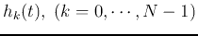 are defined on the interval 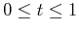. The shape of the specific function 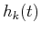 of a given index  depends on two parameters t and :

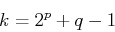

For any value of 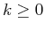,  and  are uniquely determined so that  is the largest power of 2 contained in  (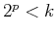) and 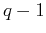 is the remainder 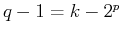. For example, when , the index  with the corresponding  and  are shown in the table:

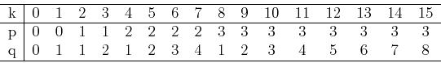

Now the Haar functions can be defined recursively as:

* When , the Haar function is defined as a constant

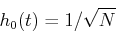

* When 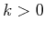, the Haar function is defined by

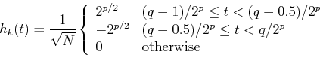

From the definition, it can be seen that  determines the amplitude and width of the non-zero part of the function, while  determines the position of the non-zero part of the function.

**MatLab Source Code:**

%haartransfrom

clc;

clear all;

close all;

i=imread('peppers.png');

subplot(231); imshow(i); title('original image');

%2D discrete wavelt transformations (single level) using Haar Basic

%functions

[ia1, ih1, iv1, id1]=dwt2(i, 'haar');

%display different coefficients

a1=ia1/255; h1=log10(ih1)*0.3; v1=log10(iv1)*0.3; d1=log10(id1)*0.3;

subplot(232); imshow(real(a1)); title('Approximation');

subplot(233); imshow(abs(h1)); title('Horizontal details');

subplot(234); imshow(abs(v1)); title('Vertical detail');

subplot(235); imshow(abs(d1)); title('diagonal detail');

%combined different coefficients in one image

transformed_i_level_1=[a1 v1 ; h1 d1];

subplot(236); imshow(abs(transformed_i_level_1)); title('level-1 transformation');

%reconstruction from level-1 transformation

rec_i=idwt2(ia1, ih1, iv1, id1, 'haar');

figure(2);

subplot(211);imshow(rec_i/255); title('Reconstruction from level-1 transformation');

%leve-2 transformation

[ia2, ih2, iv2, id2]=dwt2(ia1, 'haar');

%combined different coefficients in one image

a2=ia2/255; h2=log10(ih2)*0.3; v2=log10(iv2)*0.3; d2=log10(id2)*0.3;

tranformed_i_level_2=[[a2 v2 ; h2 d2] v1 ; h1 d1];

subplot(212); imshow(abs(tranformed_i_level_2)); title('Level-2 transformation');

**Input and Output:**





(ii) One dimensional Discrete Wavelet Transform: A discrete wavelet transform(DWT) is any [wavelet transform](https://en.wikipedia.org/wiki/Wavelet_transform) for which the [wavelets](https://en.wikipedia.org/wiki/Wavelet) are discretely sampled. As with other wavelet transforms, a key advantage it has over [Fourier transforms](https://en.wikipedia.org/wiki/Fourier_transform) is temporal resolution: it captures both frequency *and* location information (location in time).

**MatLab Source Code:**

clc, close all;

clear all;

X=imread('peppers.png');

figure(1);

subplot(1,2,1);

imshow(X);

title('Original Image');

X= double(X);

i=imresize(X,[512 512]);

subplot(1,2,2);

imshow(i);

title('Resize Image');

sX=size(X);

[LL,LH,HL,HH]= dwt2(X,'db1');

figure(2)

subplot(2,2,1);imshow(LL);title('LL band of image');

subplot(2,2,2);imshow(LH);title('LH band of image');

subplot(2,2,3);imshow(HL);title('HL band of image');

subplot(2,2,4);imshow(HH);title('HH band of image');

**Input and Output:**



(iii) Discrete Cosine Transform of an image: **Discrete Cosine Transform (DCT)** is an orthogonal transformation method that decomposes an image to its spatial frequency spectrum. It expresses a finite sequence of data points in terms of a sum of cosine functions oscillating at different frequencies. It is used a lot in compression tasks, e..g image compression where for example high-frequency components can be discarded. It is a type of Fourier-related Transform, similar to discrete fourier transforms (DFTs), but only using real numbers.

**MatLab Source Code:**

%discrete cosine transformation

clc;clear all; close all;

img=imread('autumn.tif');

img=rgb2gray(img);

subplot(131); imshow(img); title('original image');

%2d discrete cosine transformation

dct_img=dct2(img);

subplot(132); imshow(log(abs(dct_img)), []); colormap(gca, jet); title('image after dct');

%inverse discrete cosine transormation

dct_img(abs(dct_img)<10)=0;

idct_img=idct2(dct_img);

subplot(133); imshow(idct_img, [0, 255]); title('Reconstructed image');

**Input and Output:**

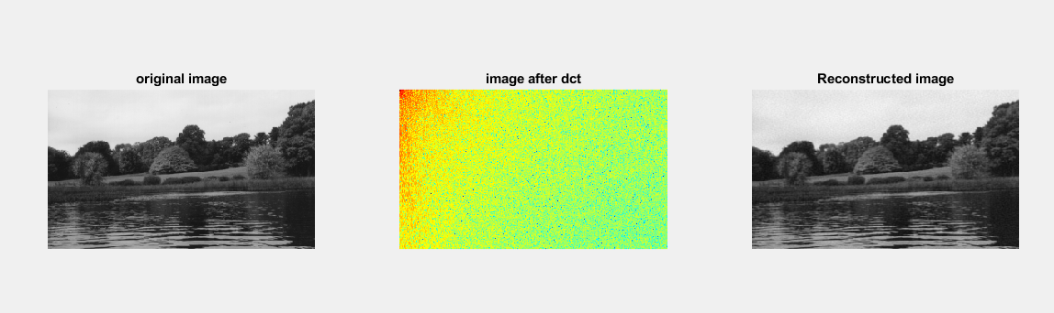

**Problem No:** 12

**Problem Title:** Write a MATLAB program for edge detection using Sobel, Canny, Prewitt, Roberts, log, zerocross filter.

**Problem Description:**

Sobel Filter: The Sobel filter is used for edge detection. It works by calculating the gradient of image intensity at each pixel within the image. It finds the direction of the largest increase from light to dark and the rate of change in that direction.

Canny Filter: The Canny edge detector is an edge detection operator that uses a multi-stage algorithm to detect a wide range of edges in images. It was developed by John F. Canny also produced a computational theory of edge detection explaining why the technique works.

Prewitt Filter: The Prewitt operator is used in [image processing](https://en.wikipedia.org/wiki/Image_processing), particularly within [edge detection](https://en.wikipedia.org/wiki/Edge_detection) algorithms. Technically, it is a [discrete differentiation operator](https://en.wikipedia.org/wiki/Difference_operator), computing an approximation of the [gradient](https://en.wikipedia.org/wiki/Image_gradient) of the image intensity function. At each point in the image, the result of the Prewitt operator is either the corresponding gradient vector or the norm of this vector. The Prewitt operator is based on convolving the image with a small, separable, and integer valued filter in horizontal and vertical directions and is therefore relatively inexpensive in terms of computations like [Sobel](https://en.wikipedia.org/wiki/Sobel_operator) and Kayyalioperators. On the other hand, the gradient approximation which it produces is relatively crude, in particular for high frequency variations in the image.

**Robert's cross operator**

Robert's cross operator is used to perform 2-D spatial gradient measurement on an image which is simple and quick to compute. In Robert's cross operator, at each point pixel values represents the absolute magnitude of the input image at that point.

**MatLab Source Code:**

%edge detection

clc; clear all; close all;

I=imread('coins.png');

figure(1),

subplot(231), imshow(I), title('Origianl image');

BW1=edge(I, 'sobel');

BW2=edge(I, 'canny');

subplot(232), imshow(BW1), title('Soble filter');

subplot(233), imshow(BW2), title('Canny filter');

I=imread('circuit.tif');

subplot(234), imshow(I), title('Origianl image');

BW1=edge(I, 'canny');

BW2=edge(I, 'prewitt');

subplot(235), imshow(BW1), title('canny filter');

subplot(236), imshow(BW2), title('prewit filter');

**Input and Output:**



**Problem No:** 13

**Problem Title:** Write a MATLAB program to implement a LPF (FIR) with cutoff 8KHz and to denoise audio.

**MatLab Source Code:**

[filename, pathname]=uigetfile(".", 'select the input audio');

[x, Fs]=audioread(num2str(filename));

%filter implementation

Fsf=44100; %sampling frequency

Fp=8e3; %passband frequency in Hz

Fst=8.4e3; %stopband frequency in Hz

Ap=1; %passband ripple in db

Ast=95; %stopband attenuation in db

%design the filter

df=designfilt('lowpassfir', 'PassbandFrequency', Fp, 'StopbandFrequency', Fst, 'PassbandRipple', Ap, 'StopbandAttenuation', Ast, 'SampleRate', Fsf);

fvtool(df) %visualize frequency response fvtool(df);

xn=awgn(x,15, 'measured'); %signal corrupted by white gaussian noise

y=filter(df, xn);

subplot(3,1,1), plot(x(1:450)); title('original signal');

subplot(3,1,2), plot(xn(1:450)); title('noisy signal');

subplot(3,1,3), plot(y(1:450)); title('filtered signal');

%use filterDesigner tool to desing IIR (Elliptic) filter with same specifications and %show filtering with this filter(Hd);

**Problem No:** 14

**Problem Title:** Write a MATLAB program to implement Echo of audio signal.

**MatLab Source Code:**

[filename, pathname]=uigetfile(".", 'select the input audio');

[x, Fs]=audioread(num2str(filename));

n=length(x); %get the length of the audio file

a=0.8; %attenuation factor

d=2000; %delay

y=zeros(n+d, 1); %initialize the output audio file

xn=padarray(x, [d,0], 0, 'Pre');

for i=(d+1):1:n

y(i-d, 1)=x(i)+a*xn(i-d);

end

**Problem No:** 15

**Problem Title:** Write a MATLAB program to record and save single and double channel audio.

**MatLab Source Code:**

recObj = audiorecorder;

disp('Start speaking.');

recordblocking(recObj, 5);

disp('End of Recording.');

play(recObj);

y = getaudiodata(recObj);

plot(y);

**Problem No:** 16

**Problem Title:** Write a MATLAB program to implement Text to Speech signal.

**MatLab Source Code:**

NET.addAssembly('System.speech');

mySpeaker=System.Speech.Synthesis.SpeechSynthesizer;

mySpeaker.Rate=0;

mySpeaker.Volume=100;

Speak(mySpeaker, 'this is digital Image and Speech Processing');